Algorithms Assignment

Daniel Tilley

C14337041

Q1 a:

Start Program

Prompt user for number of files

Get number of files

For i = 0, i < number of files do

Prompt user for file name

Get File name

If Open file != NULL Then

Print “File Opened Successfully”

End If

For j=Last_pos, j<n do

Read Record [j]

Convert Record.Key to upper case // *comparison reason*

If Read = EOF Then

Break

End If

Last_pos = j

Call Insertion Sort Function (data, last_pos)

End For

Else

Print “File Cannot Be Opened”

End Else

Close File

End For

Call Bubble Sort Function (data)

//Insertion sort function

For i = last_pos-10, i < last_pos do

Current = data[i]

j = i

While A[j-1] > current

Data[j] = data[j-1]

j --

End while

A[j] = current

End for

//Bubble sort function

While not sorted

Flag = 1

For j = 0 to j < N-1 do

If Data[j] > Data[j+1]

Flag = 0

Temp = Data[j]

Data[j] = Data[j+1]

Data[j+1] = temp

End if

End for

End for

End Program

Q1 b: The big O for this algorithm can been seen in separate ways. If the data is read in is already sorted then the big O in each case of the insertion sort will be O(n). However if the data is not already pre-sorted, the the big O for each insertion sort will be O(n^2) as the data will have to be sorted. For Bubble sort, the big O will always be O(n^2) as the combined list will have to be sorted. Overall the big O will always be O(n^2) due to the fact that both algorithms use two loops to sort the data and bubble sort will always have to sort the data.

Q2 a: Flowchart used for searching colleges.

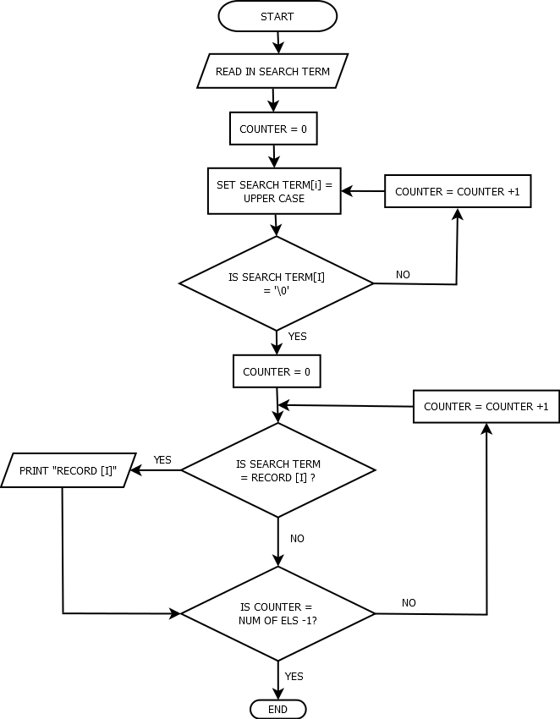

Q2 b: The big O of this algorithm in O(n) as it uses one loop to search. The algorithm converts the users search term so that it matches the term it is searching for in records. It then searches through the array one by one using a loop and prints the data one by one if a match is found.

Q3 a: Flowchart used for searching names.

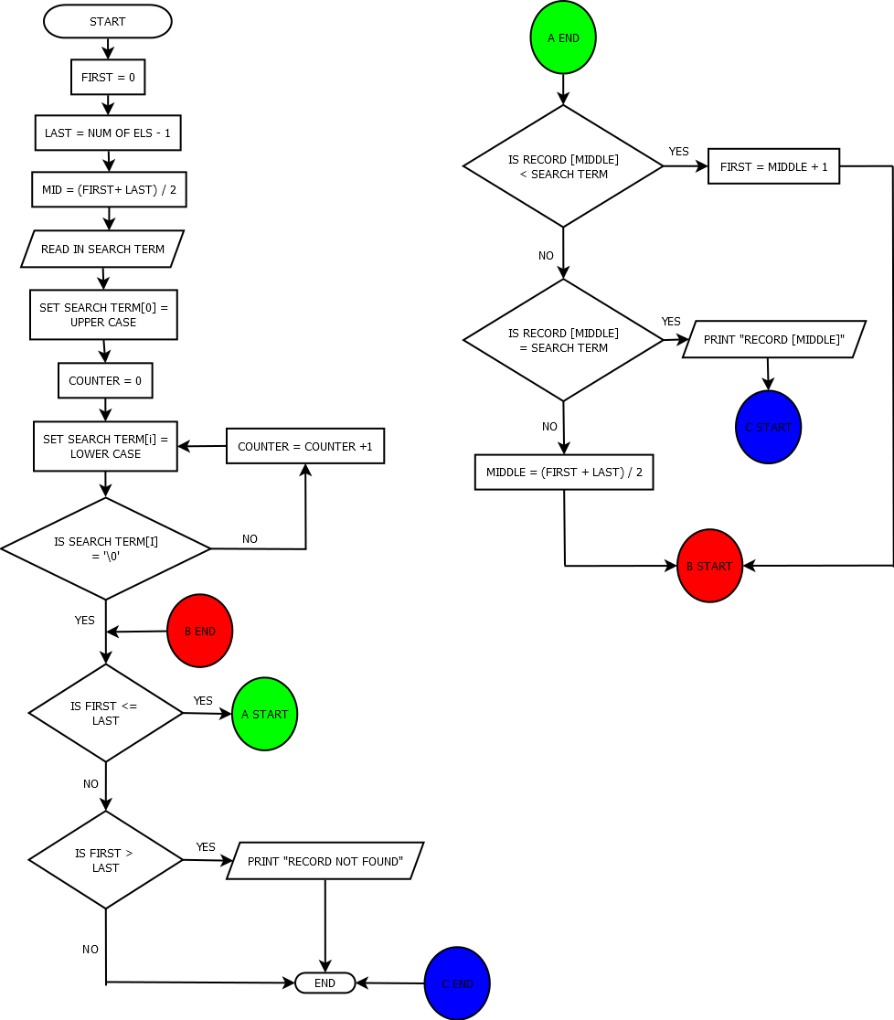

Q3 b: The big O of this algorithm in O(log n) as it uses a divide and conquer approach and on each call it half’s the search time taken. The algorithm uses a binary search to divide the list up and make searching for a single person’s name a lot quicker.